**[ Lab no 01 ] [ CSC - 113 COMPUTER PROGRAMMING ]**

**[ PROGRAMMING BASIC ]**

Task # 01 : Write a program to print your profile using C#.

**SOLUTION :**

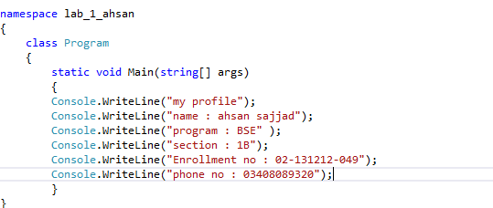

**0UTPUT :**

